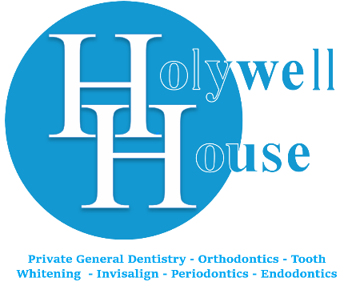

Private Minor Oral Surgery Referral Form
Please save this referral along with any x-rays and email to holywell.house@nhs.net

Patient Details:
Title: Surname: Forename:

Address:

Date of Birth:

Mobile Phone: Home Phone:

Email:

I would be grateful if you could arrange an appointment for the above patient on a private basis.

X-rays attached? Yes / No (delete as appropriate)

Provisional Diagnosis:

Requested Treatment:

Medical Conditions:

Yours Sincerely,

....................................................................
(Referring Practitioner)

Practice Name and Address:

